Test Case: tc001_SPX_Dev5_Consulta_Administracion_Accesos
Step 1 - Enter username and password and click to button Enter : Credentials Entered
Image file-name: QC_Testing-tc001_SPX_Dev5_Consulta_Administracion_Accesos-dic. 26 2025, 03 12 51 p. m.

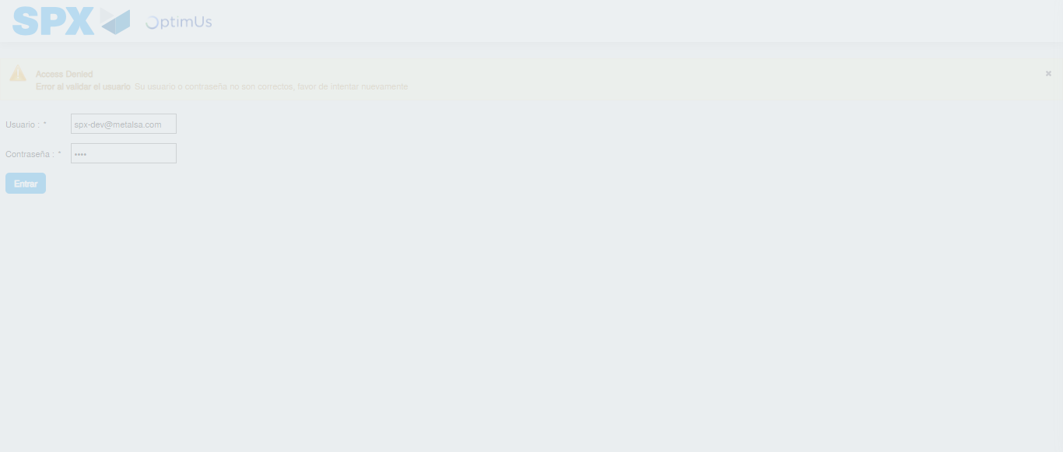Image file-name: QC_Testing-tc001_SPX_Dev5_Consulta_Administracion_Accesos-dic. 26 2025, 03 12 52 p. m.

Step 2 - Select to UEN and Access to Administraci�n de Accesos: UEN Correctly selected and Correct access
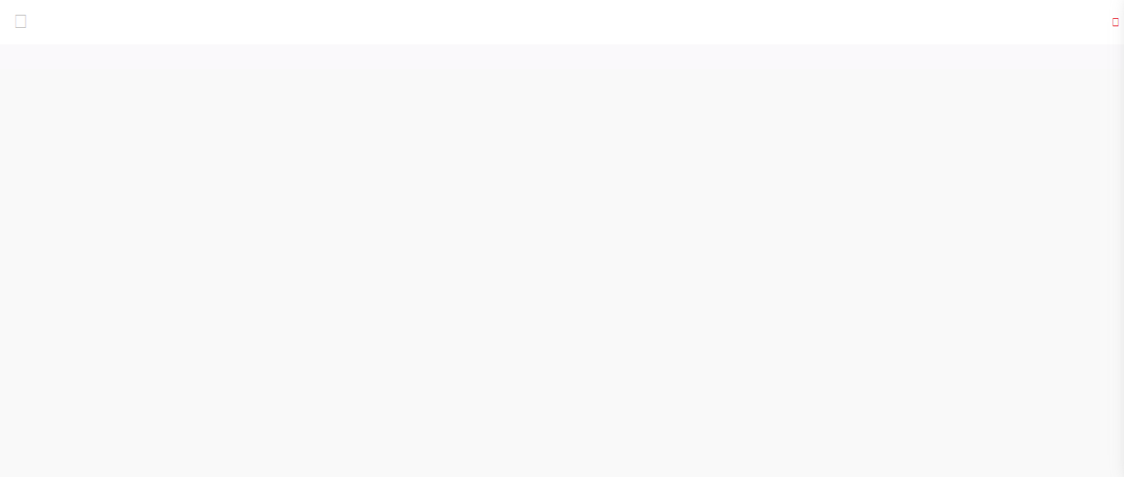Image file-name: QC_Testing-tc001_SPX_Dev5_Consulta_Administracion_Accesos-dic. 26 2025, 03 13 00 p. m.

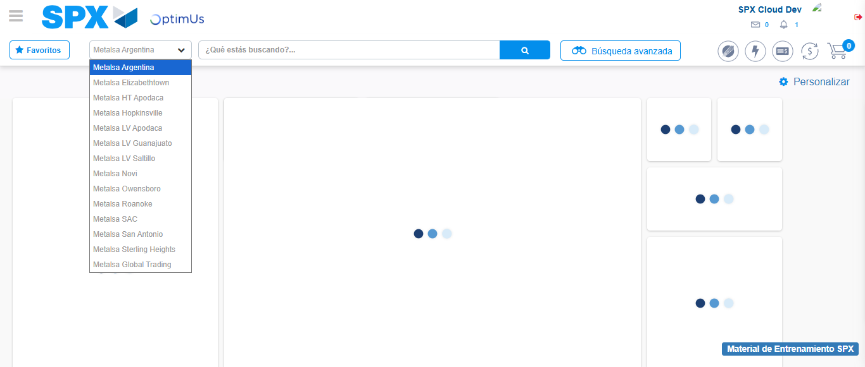Image file-name: QC_Testing-tc001_SPX_Dev5_Consulta_Administracion_Accesos-dic. 26 2025, 03 13 02 p. m.

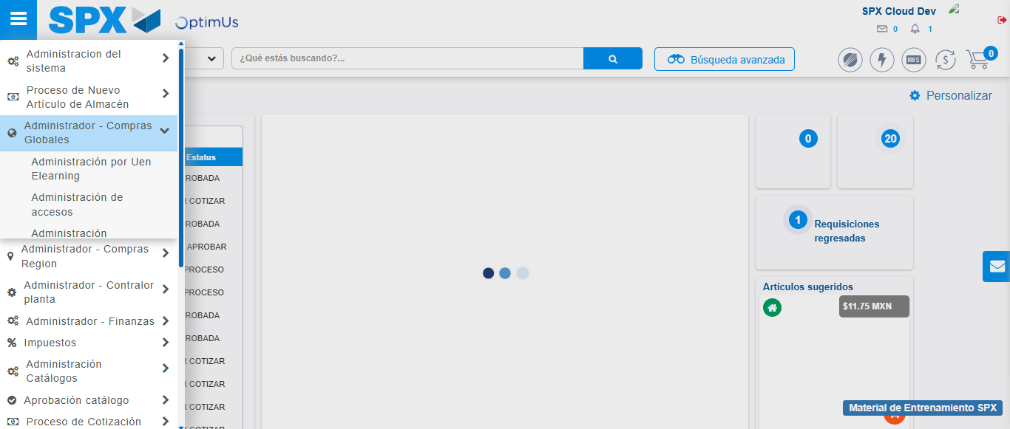Image file-name: QC_Testing-tc001_SPX_Dev5_Consulta_Administracion_Accesos-dic. 26 2025, 03 13 03 p. m.

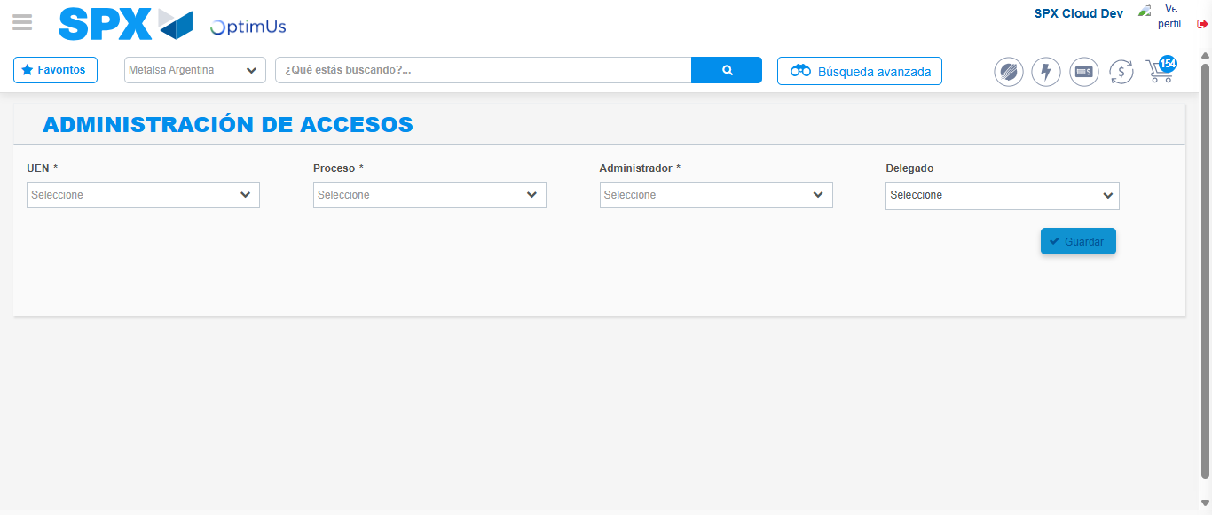Image file-name: QC_Testing-tc001_SPX_Dev5_Consulta_Administracion_Accesos-dic. 26 2025, 03 13 08 p. m.

Step 3 - Review information on Aprobaci�n Catalogos: Correct Data
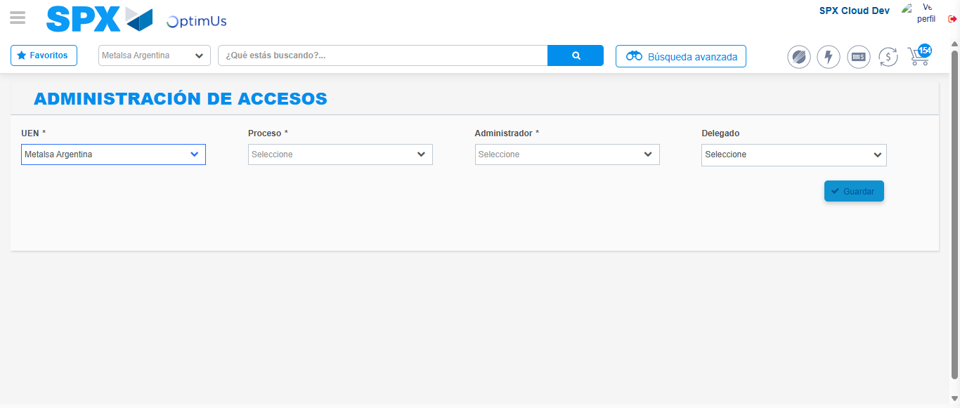Image file-name: QC_Testing-tc001_SPX_Dev5_Consulta_Administracion_Accesos-dic. 26 2025, 03 13 09 p. m.

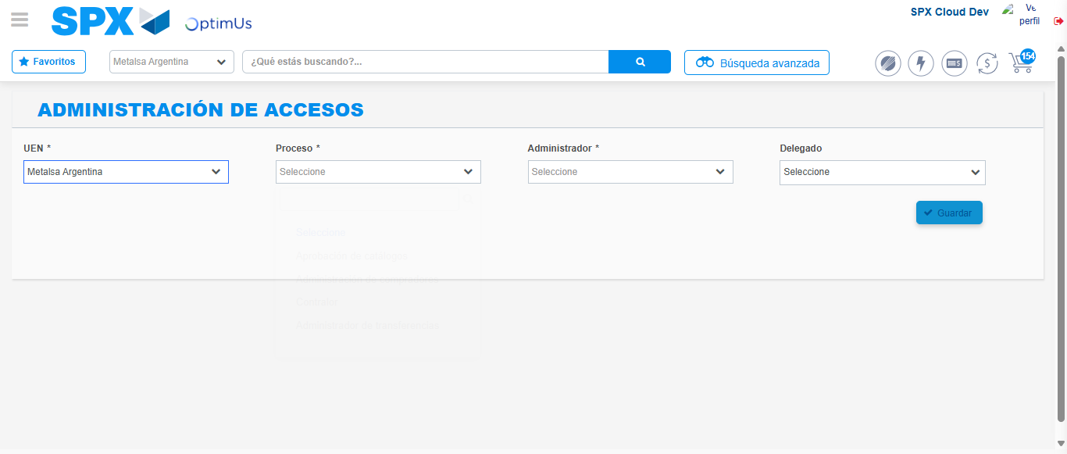Image file-name: QC_Testing-tc001_SPX_Dev5_Consulta_Administracion_Accesos-dic. 26 2025, 03 13 10 p. m.

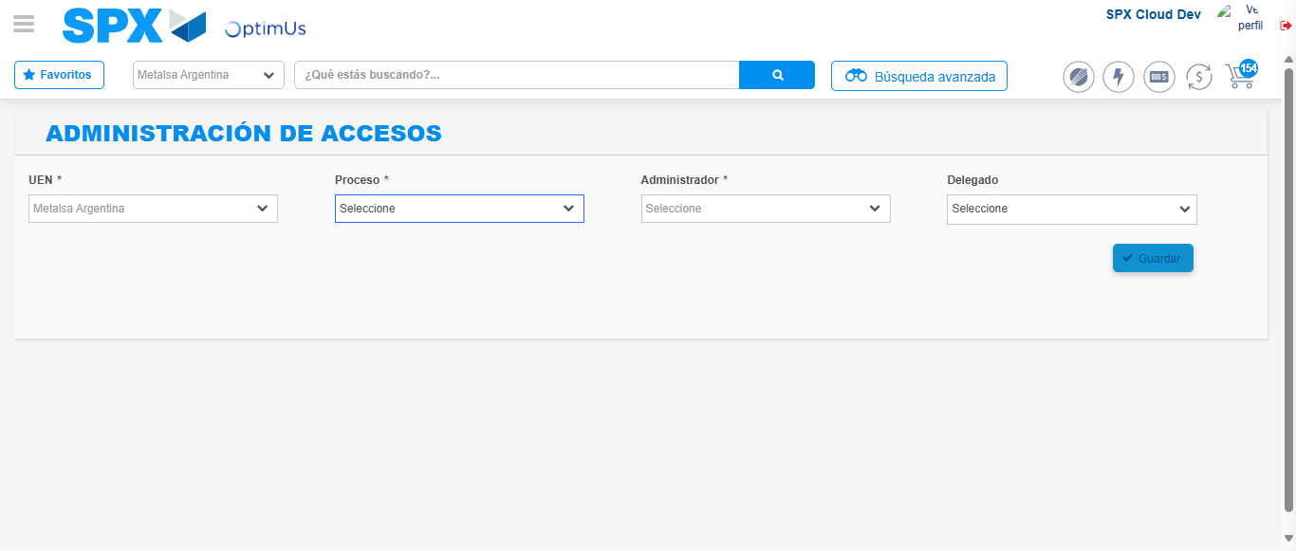Image file-name: QC_Testing-tc001_SPX_Dev5_Consulta_Administracion_Accesos-dic. 26 2025, 03 13 35 p. m.

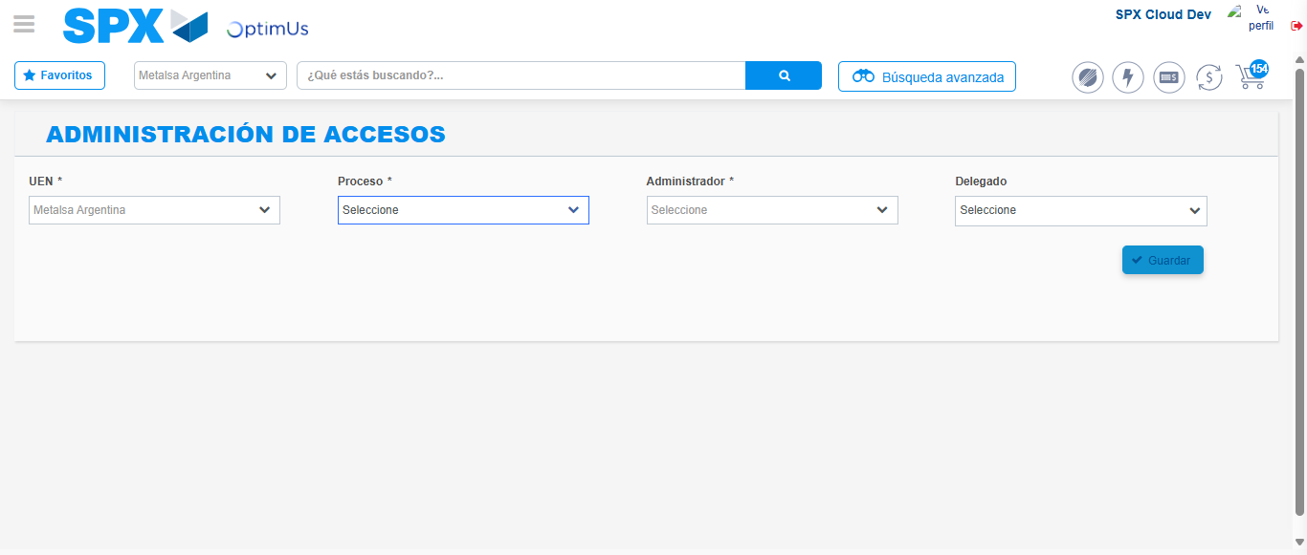Image file-name: QC_Testing-tc001_SPX_Dev5_Consulta_Administracion_Accesos-dic. 26 2025, 03 14 01 p. m.

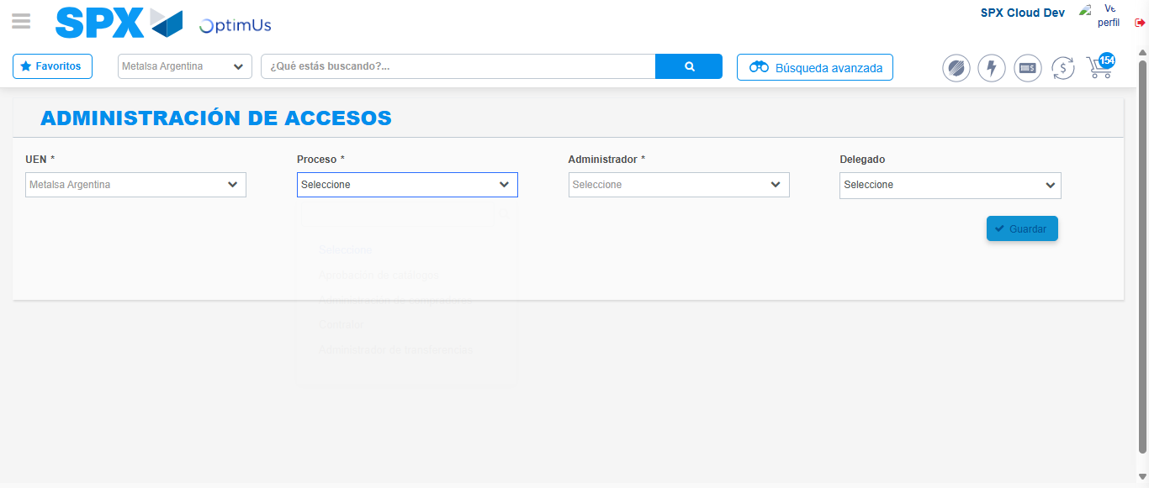Image file-name: QC_Testing-tc001_SPX_Dev5_Consulta_Administracion_Accesos-dic. 26 2025, 03 14 16 p. m.

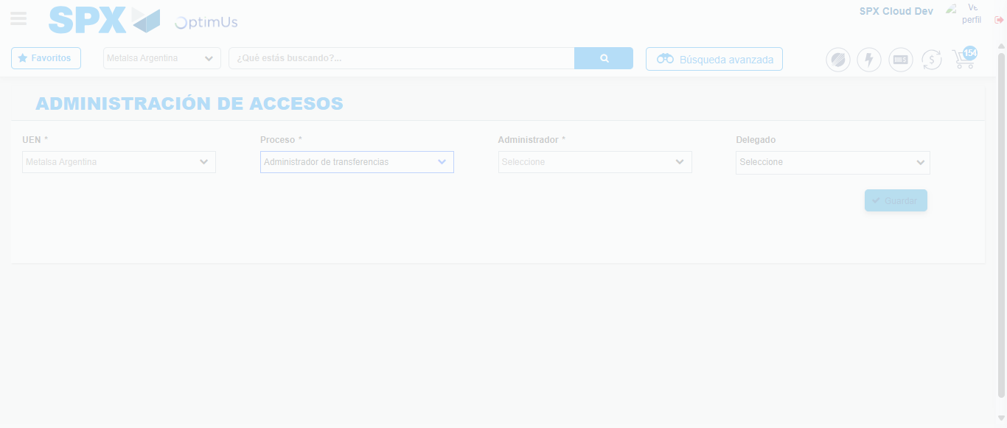Image file-name: QC_Testing-tc001_SPX_Dev5_Consulta_Administracion_Accesos-dic. 26 2025, 03 14 17 p. m.

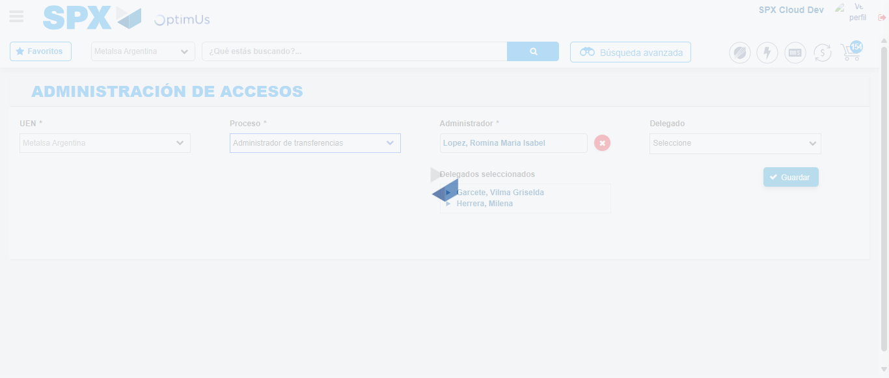Image file-name: QC_Testing-tc001_SPX_Dev5_Consulta_Administracion_Accesos-dic. 26 2025, 03 14 18 p. m.

